COLLAGE OF COMPUTING:DEPARTEMENT OF COMPUTER SCINCE
DEBRE BERHAN UNIVERSITY
BASE ABLL
ORGANIZATION MANAGEMENT SYSTEM

PREPARED BY:
NAME ID
MAKBEL KEBEDE…………………………………………………………………………….1601325
PETROS ASSEGID…………………………………………………………………………….1601567
KIDIST YITBAREK……………………………………………………………………………….16012

Table of Contents
1.Introduction ....................................................................................................................................2
1.1Background................................ ………………………………………………………………………………..………………2
1.3 Problems in the Existing System…………………………………………..........................2
1.4.1 General Objective………………………………………………………………..……………..2
1.4.2 Specific Objectives……………………………………………………………………………..………...2
1.6 Database Development Methodology……………………………………………………...………...2
1.5 Scope of the Project…………………………………………………………………..…………2
1.6 Database Development Methodology………………………………………….…………..3

2 . Database Design …………………………………………………………………………………………………..…………….….3

2.1. Conceptual Database Design ……………………………………………………………………………..………………3

2.1.1. Entities and Their Descriptions……………………………………………….…………...3
2.1.2. Enhanced ER diagram……………………………………………………………………………………..…………...7
2.1.5 The logical database design(relational model)……………………………………………………………..8

2.1.6 Validate model with normalization……………………………………………………………………………………..8
2.1.6.Physical data base design…………………………………………………………………………..………….…..12
2.2. Implementation and testing…………………………………………………………………………..…………….12
2.2.1 The SQL script for creating the data base………………………………………………..………...........13 References ....................................................…………………………………………………………………………………..18

1. Introduction
1.1 Background
Baseball organizations, such as major leagues, require efficient systems to manage vast amounts of data, including player statistics, team details, game outcomes, and personnel records. Traditional manual methods are error-prone and lack scalability. This project aims to design and implement a robust database system to streamline operations.
1.3 Problems in the Existing System
- Data redundancy across spreadsheets and paper records.
- No centralized system for tracking relationships (e.g., players to teams, umpires to games).
- Limited ability to query historical data (e.g., lifetime player stats).
1.4.1 General Objective
Develop a centralized database system to manage all aspects of a baseball organization.
1.4.2 Specific Objectives
- Design an EER diagram to model entities and relationships.
- Implement the database using SQL Server.
- Ensure data integrity through constraints and normalization
1.5 Scope of the Project
- Included: Player stats, team management, game schedules, umpire assignments, hit tracking.
- Excluded: Fan interactions, ticket sales, merchandise management.
1.6 Database Development Methodology
Follow the Systems Development Life Cycle (SDLC):
- Requirements Analysis
- Conceptual Design (EER Diagram)
- Logical Design (Relational Schema)
- Physical Design (SQL Implementation)
- Testing & Deployment

2 . Database Design

2.1. Conceptual Database Design .

2.1.1. Entities and Their Descriptions
Entities and Attributes
- Personnel (Strong Entity)
  - Attributes: ID, F_name, L_name, Role, DOB, POB
  - The personnel table represents individuals who can have different roles, such as coaches, managers, and umpires.
- Player (Weak Entity)
  - Attributes: Team_ID, Setting Average, Number of Hits, Batting Orientation
  - Dependent on the Personnel entity since it is identified through ID. It represents players with specific attributes related to performance.
- Coach (Strong Entity)
  - Attributes: ID, Team_ID
  - Coaches are directly related to a specific Personnel entry and a Team.
- Manager (Strong Entity)
  - Attributes: ID, Team_ID
  - Managers are directly related to a specific Personnel entry and a Team.
- Umpire (Strong Entity)
  - Attributes: ID
  - Umpires are part of Personnel, uniquely identified and separate from other roles.
- Team (Strong Entity)
  - Attributes: Team_ID, Team_name, City, League, Division
  - Represents teams that participate in the league, with unique identifiers and additional details like location and division.
- Game (Strong Entity)
  - Attributes: UID, Date, Home Team, Visiting Team, Home Team Runs, Visiting Team Runs, Home Team Hits, Visiting Team Hits, Winner, Visiting Team Pitcher
  - Represents a specific game event with detailed information about the participating teams and their performance.
- Pitcher (Weak Entity)
  - Attributes: ERA
  - Dependent on the Player entity, specifically representing players who are pitchers with a unique statistic: Earned Run Average (ERA).

Relationships
- Personnel and Player
  - Relationship: A Personnel can be a Player.
  - Type: Weak entity relationship, where Player relies on the ID from Personnel.
- Personnel and Coach
  - Relationship: A Personnel can be a Coach.
  - Cardinality: One-to-One or One-to-Many.
  - Type: Strong entity relationship.
- Personnel and Manager
  - Relationship: A Personnel can be a Manager.
  - Cardinality: One-to-One or One-to-Many.
  - Type: Strong entity relationship.
- Personnel and Umpire
  - Relationship: A Personnel can be an Umpire.
  - Cardinality: One-to-One or One-to-Many.
  - Type: Strong entity relationship.
- Team and Game
  - Relationship: A Team can participate in multiple Games.
  - Cardinality: One-to-Many.
  - Attributes: Home Team, Visiting Team.
- Player and Team
  - Relationship: A Player is associated with a specific Team.
  - Cardinality: Many-to-One.
- Pitcher and Player
  - Relationship: A Pitcher is a type of Player.
  - Type: Weak entity relationship, as it inherits the ID and other attributes from the Player entity.

Key Highlights
- Strong Entities
  - Entities like Personnel, Team, and Game are independent and have unique identifiers.
- Weak Entities
  - Entities like Player and Pitcher are dependent on their parent entities and cannot exist without them.
- Relationship Complexity
  - The diagram efficiently handles multiple relationships, especially with Personnel, which serves as a superclass for several entities (Player, Coach, Manager, and Umpire).
- Attributes
  - Each entity is well-defined with attributes that represent real-world characteristics, making the database comprehensive.
Table Definitions:
Below are tables generated based on the entities and their attributes:
- Personnel Table: Columns: ID, F_name, L_name, Role, DOB, POB
- Player Table: Columns: ID, Team_ID, Setting Average, Number of Hits, Batting Orientation
- Coach Table: Columns: ID, Team_ID
- Manager Table: Columns: ID, Team_ID
- Umpire Table: Columns: ID
- Team Table: Columns: Team_ID, Team_name, City, League, Division
- Game Table: Columns: UID, Date, Home Team, Visiting Team, Home Team Runs, Visiting Team Runs, Home Team Hits, Visiting Team Hits, Winner, Visiting Team Pitcher
- Pitcher Table: Columns: ID, ER

2.1.2. Enhanced ER diagram
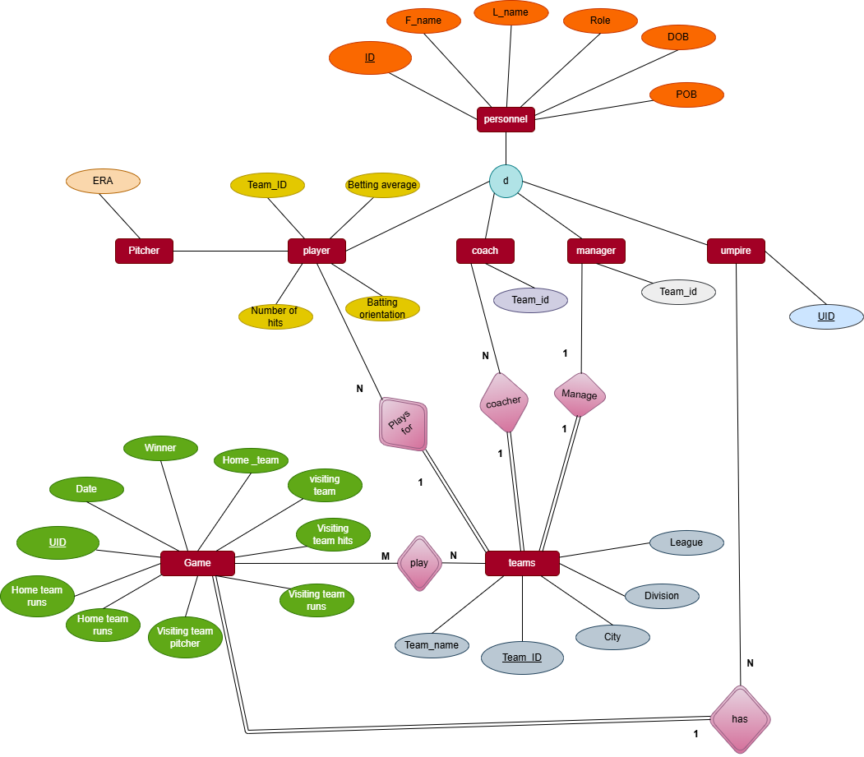

2.1.3 Logical diagram (relational model)
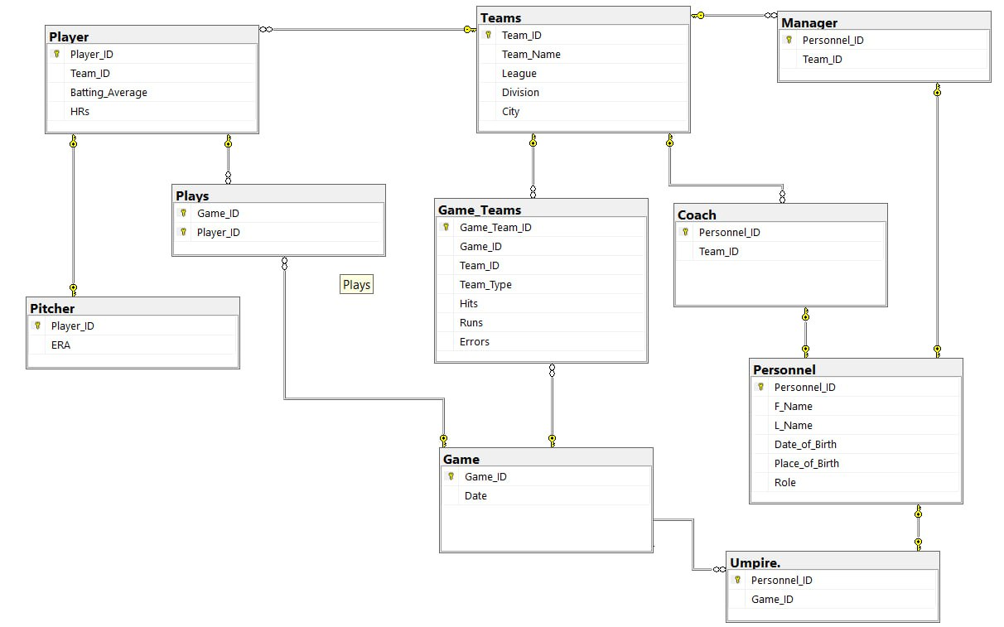

2.1.4 Validate model with normalization
the steps of First Normal Form (1NF) and Second Normal Form (2NF) by choosing Personnel for 1NF and Player for 2NF.

Step 1: Convert the Personnel Table to 1NF
- .Original Personnel Table:
The original table might have repeating groups or multiple values in a single field, which violates 1NF.
ID | F_name | L_name | Role | DOB | POP
1 | Petros | Assegid | Coach | 1980-05-12 | Debreberhan
2 | Makbel | Kebede | Manager | 1975-08-25 | Ataye
3 | Yohanis | G/egziabher | Umpire | 1982-02-10 | Gonder
4 | Worku | Aytenew | Coach, Umpire | 1970-03-15 | Addis Ababa
.

Issues with the Original Table:
- The "Role" column has multiple values (e.g., Coach, Umpire for ID 4).
- It is not in 1NF because a column contains non-atomic values.
1NF Table:
We resolve the repeating groups by creating separate rows for each role.
ID | F_name | L_name | Role | DOB | POP
1 | Petros | Assegid | Coach | 1980-05-12 | Debreberhan
2 | Makbel | Kebede | Manager | 1975-08-25 | Ataye
3 | Yohanis | G/egziabher | Umpire | 1982-02-10 | Gonder
4 | Worku | Aytenew | Coach | 1970-03-15 | Addis Ababa
4 | Worku | Aytenew | umpire | 1970-03-15 | Addis Ababa

Key Points After 1NF:
- Each column contains atomic values.
- There are no repeating groups; each role for a person is in its own row.

Step 2: Convert the Player Table to 2NF
Original Player Table:
The original table may have partial dependencies, which violate 2NF
Player_ID |  | Batting_Avg | HRs | ERA
  Team_ID
1 | 1 | 0.235 | 15 | 2.75
2 | 2 | 0.289 | 20 | 3.10
3 | 3 | 0.300 | 25 | 2.90
4 | 4 | 0.275 | 18 | 3.50
Issues with the Original Table:
- The ERA (Earned Run Average) depends only on Player_ID, not on the entire composite key (if there is one), which violates 2NF.
Decompose the Table into 2NF:
.Split the table into two tables:
  - Player Table: Contains information that depends on the composite key.
  - Player Performance Table: Contains information that depends only on Player_ID
1.Player table
Player_ID | Team_ID
1 | 1
2 | 2
3 | 3
4 | 4
2.Player Performance Table:
Player_ID | Batting_Avg |  | ERA
  HRs
1 |  | 15 | 2.75
  0.325
2 |  | 20 | 3.10
  0.289
3 | 0.300 | 25 | 2.90
4 |  | 18 | 3.50
  0.275
Key Points After 2NF:
- All partial dependencies are removed.
- Each non-prime attribute depends on the whole primary key, not just part of it.
Step 3: Convert the Teams Table to 3NF
Original team table:
Team_ID | Team_name | league | Division | City
1 | Fasil kenema | EL | East | Gonder
2 | waliawoch | NL
  West
  Hawassa
3 | Ethiobank | EL
  East
  Addis Ababa
4 | wolkite | NL | Central | Wolkite

Issues with the Original Table:
- The City column is transitively dependent on Team_Name, which violates 3NF.
For example, Gonder is determined by Fasil Kenema rather than directly by the Team_ID

3NF Tables:
- Teams Table:
Team_id | Team_name | League | Division | City_ID
1 | Fasil kenema | EL | East | 1
2 | Waliawoch | NL | West | 2
3 | Ethiobank | EL |  | 3
  East
4 | Wolkite |  |  | 4
  NL
  Central
2.Cities Table
City_ID | City
1 | Gonder
2 | Hawassa
3 | Addis Ababa
4 | Wolkite

Key Points After 3NF:
- The Teams Table now has a City_ID foreign key pointing to the Cities table, ensuring that the City information is not transitively dependent on Team_ID.
- Each table has attributes that depend only on the primary key and no transitive dependencies exist.

Final 3NF Schema:
- Personnel Table (1NF): Already converted in Step 1.
- Player Table (2NF): Already converted in Step 2.
- Teams Table (3NF): Converted above with no transitive dependencies.
- Other Tables: For other tables, repeat similar steps as needed based on their attributes and dependencies.
2.1.5 Pysical data base design
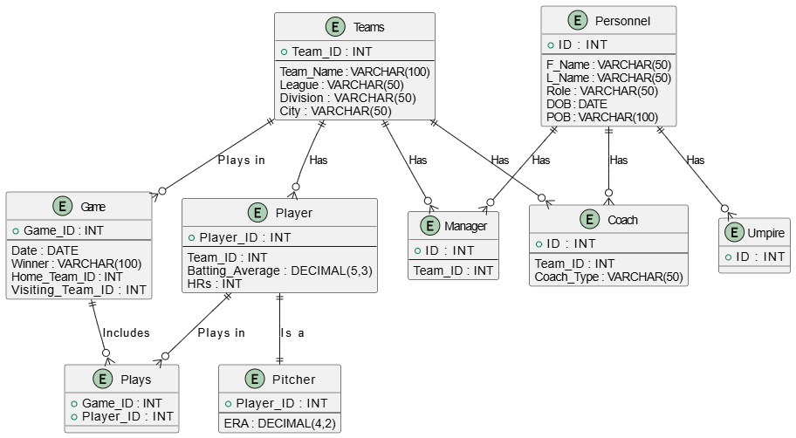

2.2. Implementation and testing
2.2.1 The SQL script for creating the data base

create database Baseballorg
USE Baseballorg
-- Creating the Personnel Table
CREATE TABLE Personnel (
ID INT PRIMARY KEY,
F_Name VARCHAR(50) NOT NULL,
L_Name VARCHAR(50) NOT NULL,
Role VARCHAR(50) NOT NULL,
DOB DATE NOT NULL,
POB VARCHAR(100) NOT NULL
);
-- Inserting Data into Personnel Table
INSERT INTO Personnel VALUES (1, 'Petros', 'Assegid', 'Coach', '1980-05-12', 'Debreberhan');
INSERT INTO Personnel VALUES (2, 'Makbel', 'Kebede', 'Manager', '1975-08-25', 'Ataye');
INSERT INTO Personnel VALUES (3, 'Yohanis', 'G/egziabher', 'Umpire', '1982-02-10', 'Gonder');
INSERT INTO Personnel VALUES (4, 'Worku', 'Aytenew', 'Coach', '1970-03-15', 'Addis Ababa');
INSERT INTO Personnel VALUES (5, 'Kebede', 'Hailu', 'Manager', '1985-11-20', 'Bahir Dar');

SELECT * FROM Personnel;

-- Creating the Teams Table
CREATE TABLE Teams(
Team_ID INT PRIMARY KEY,
Team_Name VARCHAR(100) NOT NULL,
League VARCHAR(50) NOT NULL,
Division VARCHAR(50) NOT NULL,
City VARCHAR(50) NOT NULL
);
-- Inserting Data into Teams Table
INSERT INTO Teams VALUES (1, 'Fasil Kenema', 'EL', 'East', 'Gonder');
INSERT INTO Teams VALUES (2, 'Waliawoch', 'NL', 'West', 'Hawassa');
INSERT INTO Teams VALUES (3, 'Ethiobank', 'EL', 'East', 'Addis Ababa');
INSERT INTO Teams VALUES (4, 'Wolkite', 'NL', 'Central', 'Wolkite');

SELECT * FROM Teams;

-- Creating the Player Table
CREATE TABLE Player(
Player_ID INT PRIMARY KEY,
Team_ID INT NOT NULL,
Batting_Average DECIMAL(5,3),
HRs INT,
FOREIGN KEY (Team_ID) REFERENCES Teams(Team_ID)
);
-- Inserting Data into Player Table
INSERT INTO Player VALUES (1, 1, 0.325, 15);
INSERT INTO Player VALUES (2, 2, 0.289, 20);
INSERT INTO Player VALUES (3, 3, 0.300, 25);
INSERT INTO Player VALUES (4, 4, 0.275, 18);

SELECT * FROM Player;

-- Creating the Pitcher Table (Subclass of Player)
CREATE TABLE Pitcher(
Player_ID INT PRIMARY KEY,
ERA DECIMAL(4,2),
FOREIGN KEY (Player_ID) REFERENCES Player(Player_ID)
);
-- Inserting Data into Pitcher Table
INSERT INTO Pitcher VALUES (1, 2.75);
INSERT INTO Pitcher VALUES (2, 3.10);
INSERT INTO Pitcher VALUES (3, 2.90);
INSERT INTO Pitcher VALUES (4, 3.50);

SELECT * FROM Pitcher;

-- Creating the Coach Table (Subclass of Personnel)
CREATE TABLE Coach(
ID INT PRIMARY KEY,
Team_ID INT NOT NULL,
Coach_Type VARCHAR(50) NOT NULL,
FOREIGN KEY (ID) REFERENCES Personnel(ID),
FOREIGN KEY (Team_ID) REFERENCES Teams(Team_ID)
);
-- Inserting Data into Coach Table
INSERT INTO Coach VALUES (1, 1, 'Head Coach');
INSERT INTO Coach VALUES (4, 3, 'Assistant Coach');

SELECT * FROM coach;

-- Creating the Manager Table (Subclass of Personnel)
CREATE TABLE Manager (
ID INT PRIMARY KEY,
Team_ID INT NOT NULL,
FOREIGN KEY (ID) REFERENCES Personnel(ID,
FOREIGN KEY (Team_ID) REFERENCES Teams(Team_ID
);
-- Inserting Data into Manager Table
INSERT INTO Manager VALUES (2, 2);
INSERT INTO Manager VALUES (5, 4);

SELECT * FROM Manager;

-- Creating the Umpire Table (Subclass of Personnel)
CREATE TABLE Umpire(
ID INT PRIMARY KEY,
FOREIGN KEY (ID) REFERENCES Personnel(ID)
);

-- Inserting Data into Umpire Table
INSERT INTO Umpire VALUES (3);
SELECT * FROM Umpire;

-- Creating the Game Table
CREATE TABLE Game (
Game_ID INT PRIMARY KEY,
Date DATE NOT NULL,
Winner VARCHAR(100) NOT NULL,
Home_Team_ID INT NOT NULL,
Visiting_Team_ID INT NOT NULL,
FOREIGN KEY (Home_Team_ID) REFERENCES Teams(Team_ID),
FOREIGN KEY (Visiting_Team_ID) REFERENCES Teams(Team_ID)
);
-- Inserting Data into Game Table
INSERT INTO Game VALUES (1, '2025-06-15', 'Fasil Kenema', 1, 2);
INSERT INTO Game VALUES (2, '2025-06-16', 'Waliawoch', 2, 1);
INSERT INTO Game VALUES (3, '2025-06-17', 'Ethiobank', 3, 4);
INSERT INTO Game VALUES (4, '2025-06-18', 'Wolkite', 4, 3);

SELECT * FROM Game;

-- Creating the Plays Table (Relationship between Player and Game)
CREATE TABLE Plays(
Game_ID INT NOT NULL,
Player_ID INT NOT NULL,
PRIMARY KEY (Game_ID, Player_ID),
FOREIGN KEY (Game_ID) REFERENCES Game(Game_ID) ,
FOREIGN KEY (Player_ID) REFERENCES Player(Player_ID)
);
-- Inserting Data into Plays Table
INSERT INTO Plays VALUES (1, 1);
INSERT INTO Plays VALUES (2, 2);
INSERT INTO Plays VALUES (3, 3);
INSERT INTO Plays VALUES (4, 4);
SELECT * FROM Plays;

Testing user table

PERSONNEL TABLE
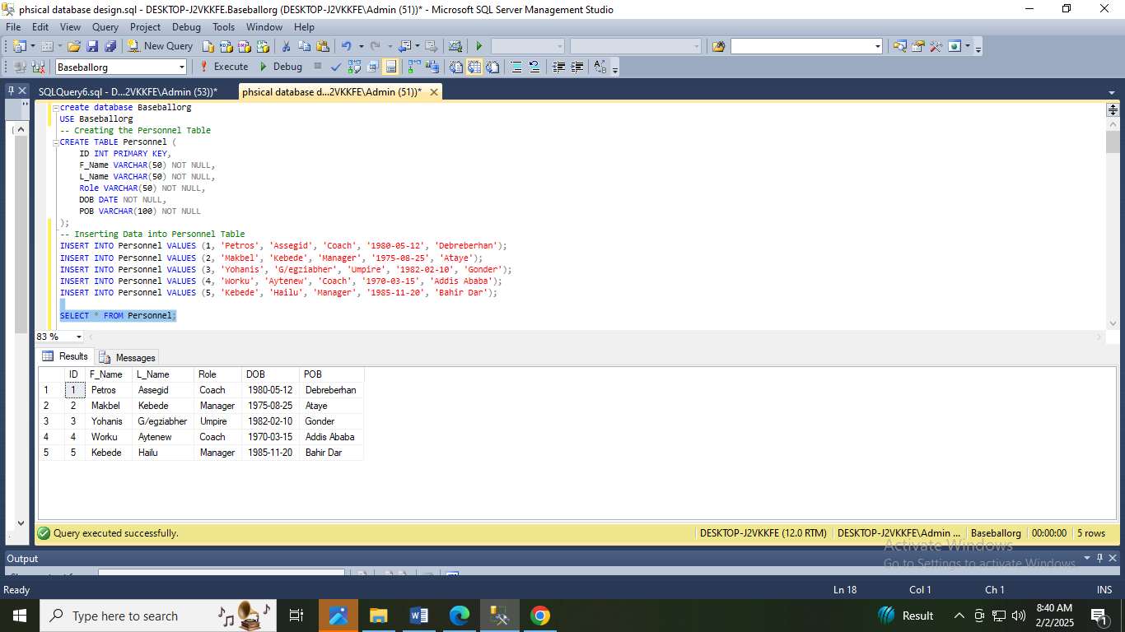

TEAM TABLE
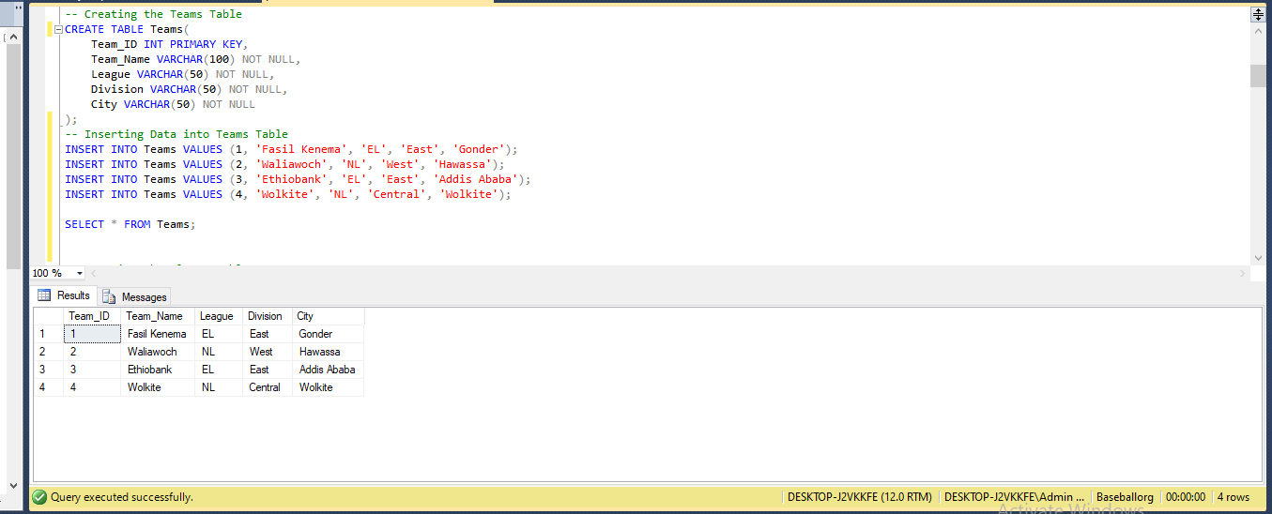

PLAYER TABLE
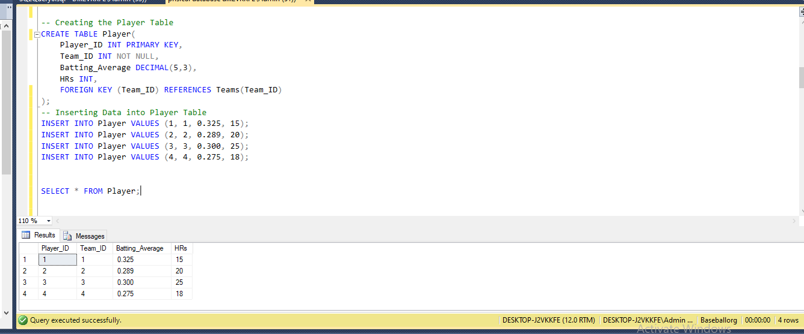

PITCHER TABLE
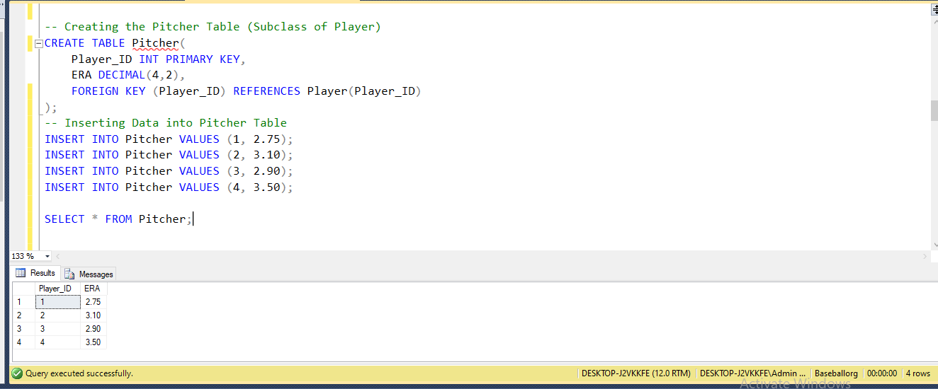
COACH TABLE
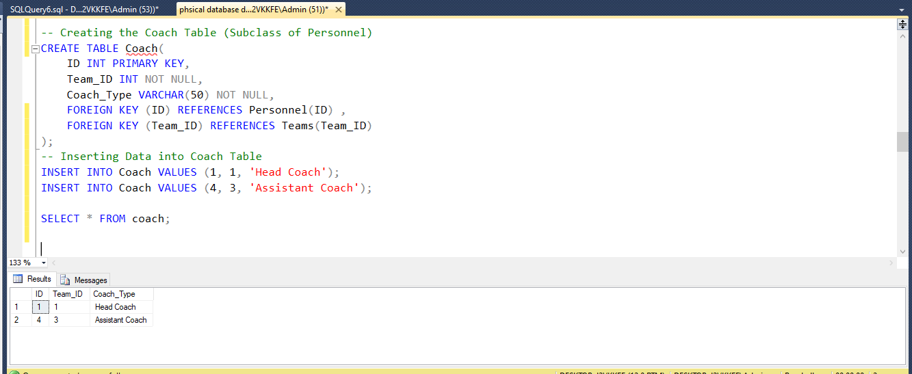

MANAGER TABLE
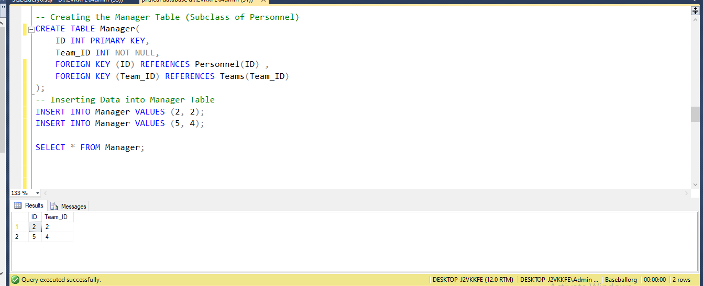

UMPIRE TABLE
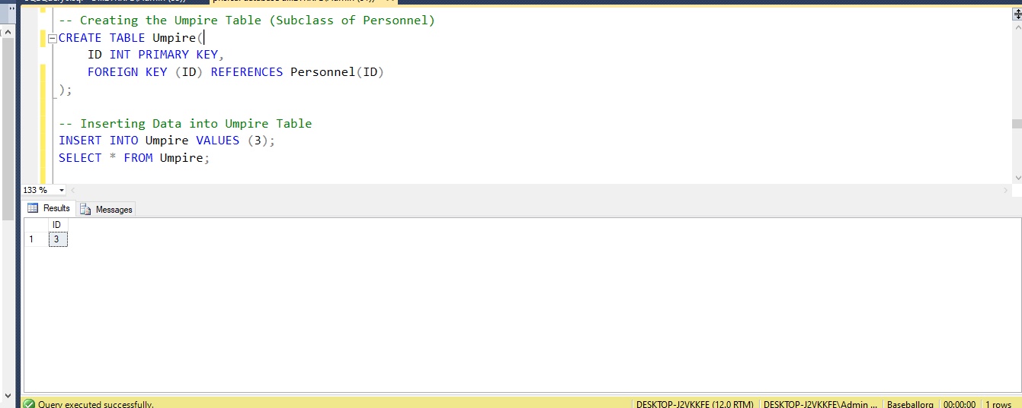

GAME TABLE
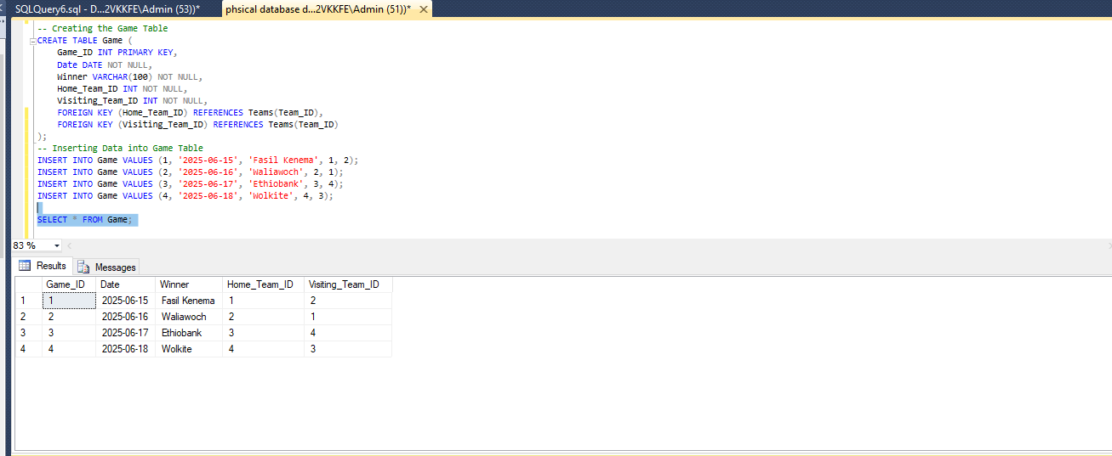

PLAYS TABLE
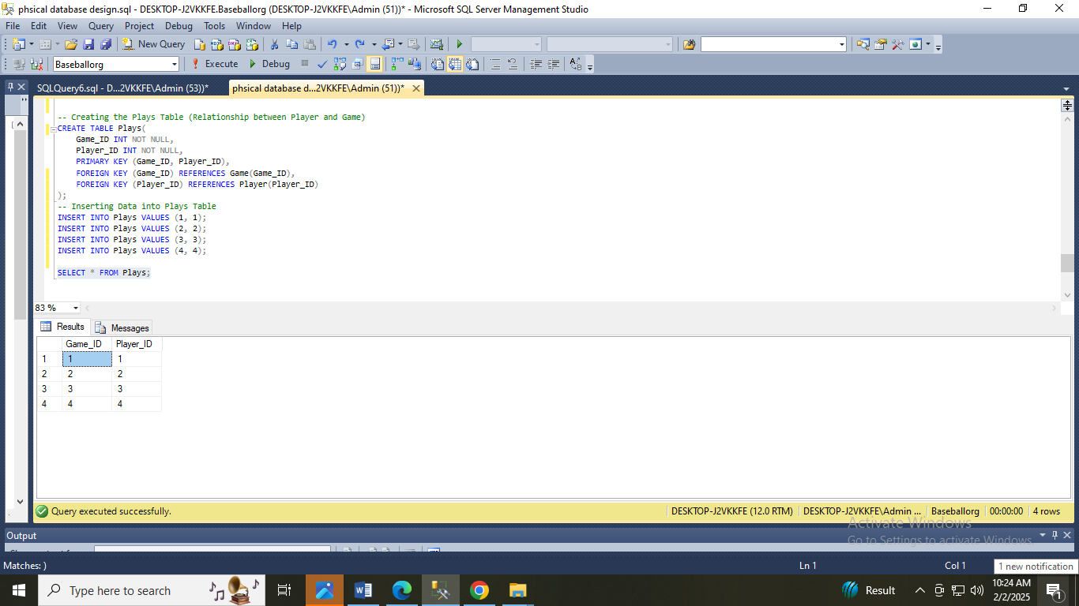

Python Connection
To interact with databases from Python, we will use pyodbc, a Python library that provides an interface for connecting to various relational database management systems (RDBMS), such as SQL Server, MySQL, and Oracle. By using pyodbc, we can establish a connection to the database, execute SQL queries, and retrieve data efficiently.
The library uses Open Database Connectivity (ODBC) to communicate with the database, providing a flexible and standardized way to work with different database systems. With pyodbc, we can fetch data and even visualize it using tools like Matplotlib for graphical representation, making it an ideal solution for fetching and interpreting data stored in a relational database.
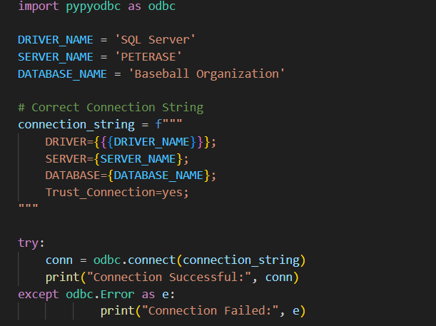

References

- W3Schools SQL Tutorial: A comprehensive introduction to SQL, covering basic to advanced topics.
W3Schools - SQL Tutorial
- Database Design Basics: An overview of fundamental principles in designing a database, including relationships and normalization.
Microsoft - Database Design
- SQL Views Overview: A guide to creating and using views in SQL, including their advantages and limitations.
TutorialsPoint - SQL Views
- SQL Constraints: Explanation of various constraints (like primary keys, foreign keys) that ensure data integrity.
W3Schools - SQL Constraints

